Infosys Springboard Virtual Internship 7.0 Completion Report

Team Details :

Frontend: Kartik Saini, Harshit Raj
Backend: S. Kavipriya
Database: Gayathri
AI integration: Kartik Saini

Batch Number: 1 : Enterprise Learning Platform with Skill & Career Guidance System
Start date : 29-06-2026
Name: Kartik Saini
Internship Duration: 40-day (12 Weeks)

Project Title
Enterprise Learning Platform with Skill and Career Guidance System

Project Objective
The Enterprise Learning Platform with Skill and Career Guidance System is an AI-assisted enterprise learning and career-guidance platform designed to help students learn through structured courses, prove their skills through assessments and certification, practice and compete on technical ability, and prepare for real careers through a role-based roadmap, resume builder, and job board. The main objectives of this project are:
  - To provide a secure, role-based platform for students and administrators.
  - To deliver structured courses broken into modules and lessons with live progress tracking.
  - To assess student understanding through AI-assisted assessments and issue verifiable certificates.
  - To guide students toward a career through a role-based Career Roadmap with a week-by-week curriculum.
  - To build career-readiness tools such as a Resume Builder and a Jobs & Internships board.
  - To provide an AI Assistant chatbot for instant, conversational help across the platform.
  - To create an Admin Dashboard that visualizes platform analytics and manages users, courses, and support. This project aims to combine secure enterprise software engineering with AI assistance to promote structured learning, verifiable skill-building, and career readiness.

Project description in detail
The Enterprise Learning Platform with Skill and Career Guidance System is a full-stack learning and career-guidance platform developed using React (Vite + Tailwind CSS) on the frontend and Spring Boot with Spring Security and JPA/Hibernate on the backend, backed by a MySQL database. The platform allows students to track their learning, build technical skills, earn verifiable credentials, and prepare for real jobs.

Landing Page:
The landing page introduces users to the platform and highlights its key features. It provides information about the purpose of the platform and encourages users to register or log in.

Authentication System:
The system includes a secure JWT-based login and registration mechanism, along with Google OAuth2 sign-in, that allows users to access their personal student dashboard based on their role (Student or Admin).

Student Dashboard & My Progress:
The dashboard is the main interface where students can view their learning insights. It displays stat cards and charts about enrolled courses, average completion percentage, courses completed, and course-wise progress.

Courses, Assessments & Certificates:
Courses are structured as Course → Module → Lesson. Each enrolled course unlocks one assessment, and passing it automatically issues a verifiable certificate with a unique ID, QR code, and public verification link.

Coding Practice, Contests & Career Roadmap:
The platform includes a standalone coding practice arena with a leaderboard, time-boxed contests with live rankings and contest certificates, and a role-based Career Roadmap (Full Stack Developer, Java Backend Developer, Frontend Developer, Python Developer, Cloud Engineer) with a 12-week curriculum and daily study plans.

Resume Builder & Jobs Board:
Students can build a resume in-app with a live ATS score, and browse a Jobs & Internships board matched to their track, applying directly using their platform profile.

AI Assistant:
An AI-powered chatbot, built on the Google Gemini API, interacts with users and answers questions instantly. It acts as a virtual assistant that can guide students in using the platform and understanding course content.

Admin Panel:
An admin panel allows administrators to monitor system activity, manage users and courses, oversee certificates, review revenue and enrollment analytics, and resolve student support tickets.
The entire system is designed to provide a simple, user-friendly interface while using advanced technology in the backend.

Timeline Overview

Week | Activities Planned | Activities Completed
Week 1 | Project objective decided, GitHub repository setup | GitHub repository created, requirements finalised for the Enterprise Learning Platform
Week 2 | Tech stack evaluation, architecture planning | React (Vite) + Tailwind and Spring Boot + MySQL architecture finalised
Week 3 | Landing page design, database setup | Landing page built; users table and MySQL schema set up
Week 4 | User authentication, JWT tokens | Login/Register done with JWT sessions and Google OAuth2 sign-in

Week | Activities Planned | Activities Completed
Week 5 | Course, module & lesson structure, enrollment | Course → Module → Lesson hierarchy and enrollment flow implemented
Week 6 | Assessment module, certificate generation | Assessments unlocked per course; auto-certificate with QR + verification built
Week 7 | Admin dashboard foundations | Course, user & certificate management screens built for Admin role
Week 8 | Progress analytics dashboard | My Progress page with stat cards and Recharts visualisations completed
Week 9 | Coding practice module | In-browser code editor, test-case evaluation, and leaderboard implemented
Week 10 | Contests and Career Roadmap | Contest registration/leaderboard and 12-week Career Roadmap with daily plans built
Week 11 | Resume Builder, Jobs board, Profile & Settings | ATS resume builder, jobs board, profile and settings, notifications implemented
Week 12 | AI Assistant, Support & Help, final testing | Gemini-powered AI Assistant integrated, support ticketing completed, project ready for evaluation

5a. Key Milestones

Milestone | Description | Date Achieved
Project Kickoff | Defined the project objectives, scope, system architecture, and responsibilities for developing the platform. | 29 June 2026
Prototype / First Draft | Developed the initial working prototype including the Spring Boot backend, JWT authentication, and basic landing/dashboard UI pages. | 8 July 2026
Mid-Term Review | Evaluated project progress, completed course/assessment/certificate flow, and reviewed the admin dashboard foundations. | 23 July 2026
Final Submission | Completed the fully functional Enterprise Learning Platform with Skill and Career Guidance System, including Career Roadmap, Coding Practice, Contests, Resume Builder, Jobs board, and AI Assistant. | 13 August  2026
Final Presentation | Demonstrated the working system highlighting authentication, learning flow, certification, career roadmap, and AI assistant features. | 1–2 September  2026

5b. Project execution details

Requirement Analysis:
The project started with identifying the main objectives of the Enterprise Learning Platform with Skill and Career Guidance System, which included building a secure, role-based learning platform that tracks student progress, issues verifiable certificates, and guides students toward a career.

System Architecture Design:

The architecture of the system was planned using a client-server model where the React frontend interacts with the Spring Boot backend over REST APIs. The backend handles authentication, business logic, and communicates with the MySQL database.

Frontend Development:
The user interface was developed using React, Vite, and Tailwind CSS. Multiple pages were created including the landing page, login/register pages, student dashboard, course pages, career roadmap, and admin dashboard to provide a smooth, responsive experience.

Backend Development:
The backend was implemented using Spring Boot with Spring Security. It handles user authentication, manages REST API routes, processes data, connects to the database, and communicates with the Google Gemini API for the AI Assistant.

Database Integration:
A MySQL database was used to store user credentials, courses, enrollments, assessments, certificates, and career-roadmap data. This ensures that all user information and analytics can be accessed and managed efficiently.

Certificate & Credentialing System Development:
An automated certificate-generation system was built to issue a unique, QR-coded, publicly verifiable certificate the moment a student passes a course assessment.

AI Assistant Integration:
The Google Gemini API was integrated into the Spring Boot backend so that the chatbot could generate real-time, conversational responses when students ask questions.

Progress Analytics Dashboard Development:
An interactive dashboard was created using Recharts to visualize learning progress through stat cards and charts. This helps students easily understand their learning trends.

Coding Practice, Contests & Career Roadmap Integration:
A coding-practice arena, time-boxed contests with live leaderboards, and a role-based career roadmap with a weekly curriculum were added to guide students from learning to job readiness.

Admin Panel and Testing:
An admin panel was implemented to monitor users and manage system activities. Finally, the entire system was tested to ensure that all modules work correctly and integrate smoothly.

Snapshots / Screenshots
Opening the project folder containing all the main files such as the frontend src directory, backend controllers, and application configuration.

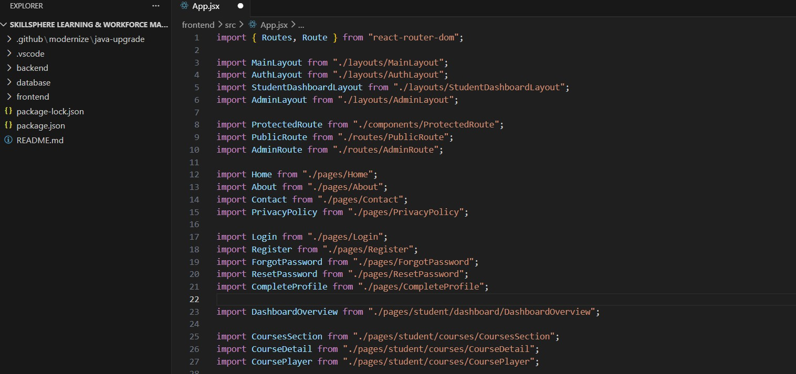
Project folder structure in VS Code

Running the Spring Boot backend in the terminal (mvn spring-boot:run).
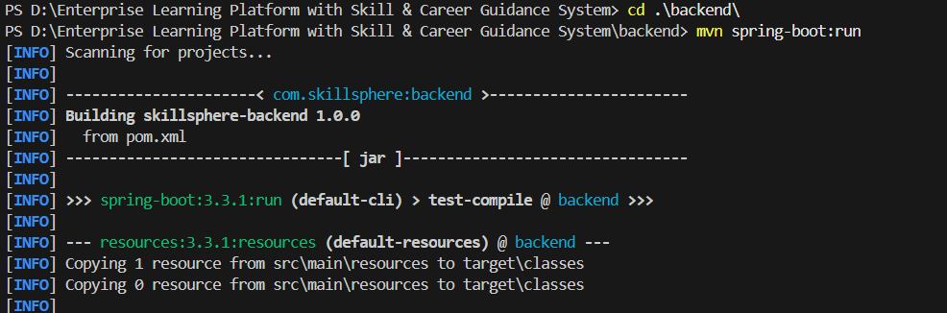
Backend startup log — Spring Boot

Running the React frontend in the terminal (npm run dev).
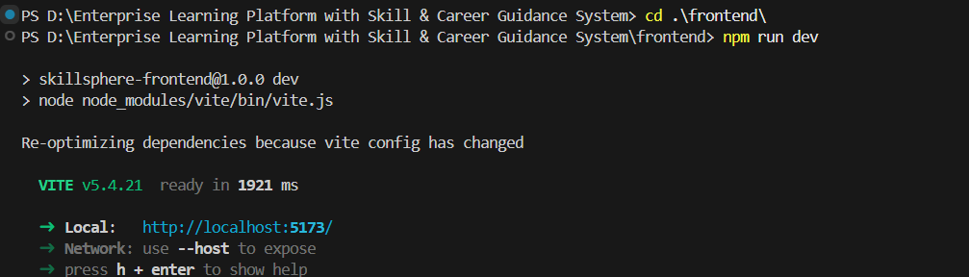
Frontend startup log — Vite dev server
- Opening the local server link provided by Vite (http://localhost:5173).
The home page of the Enterprise Learning Platform with Skill and Career Guidance System appears on the browser.

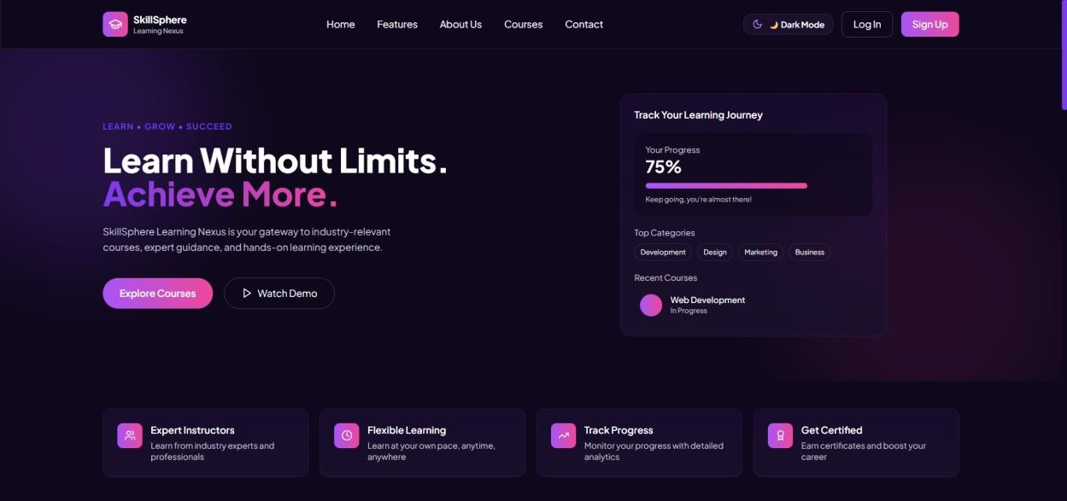
Landing Page

The next page includes login for an existing user, or signing in directly with Google.
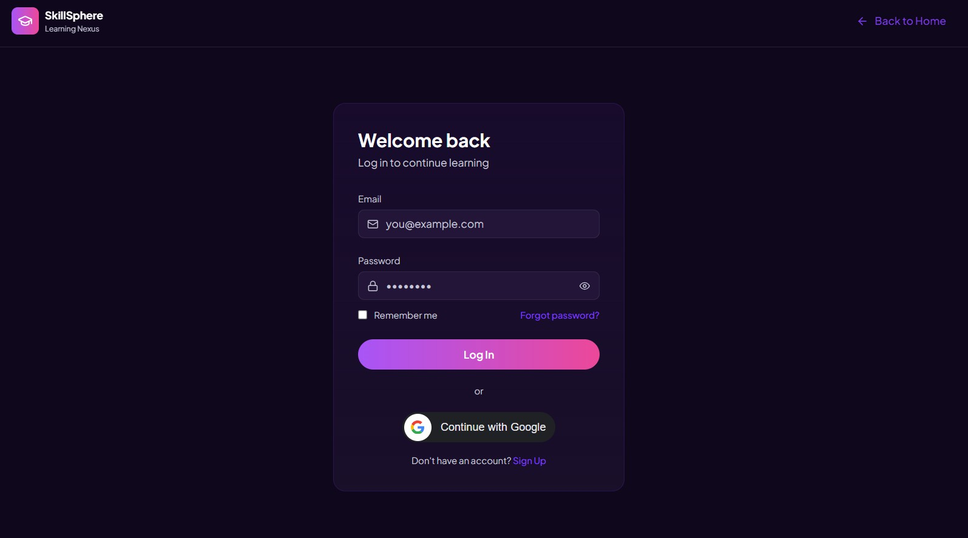
Login Page
New users can also create an account, or sign up instantly with Google.

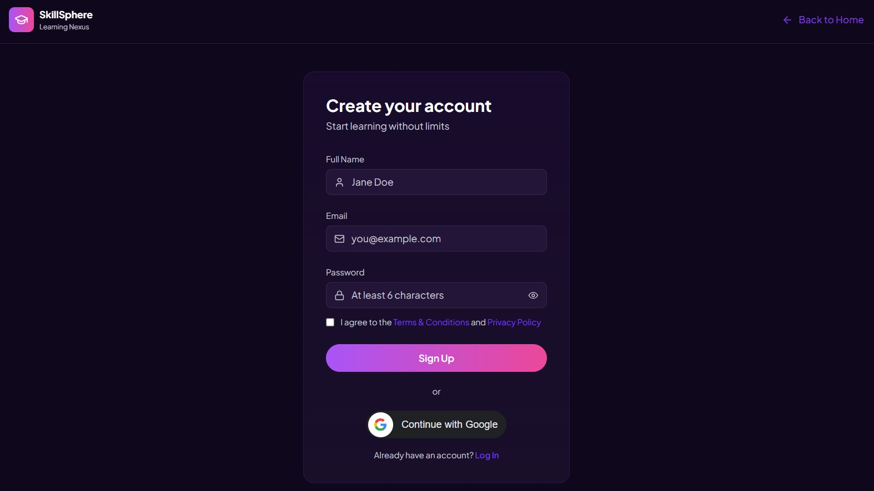
Register / Sign Up Page
The Student Dashboard displays enrolled courses, progress stats, streaks, and quick access to the Career Roadmap, Coding Practice, and AI Assistant.
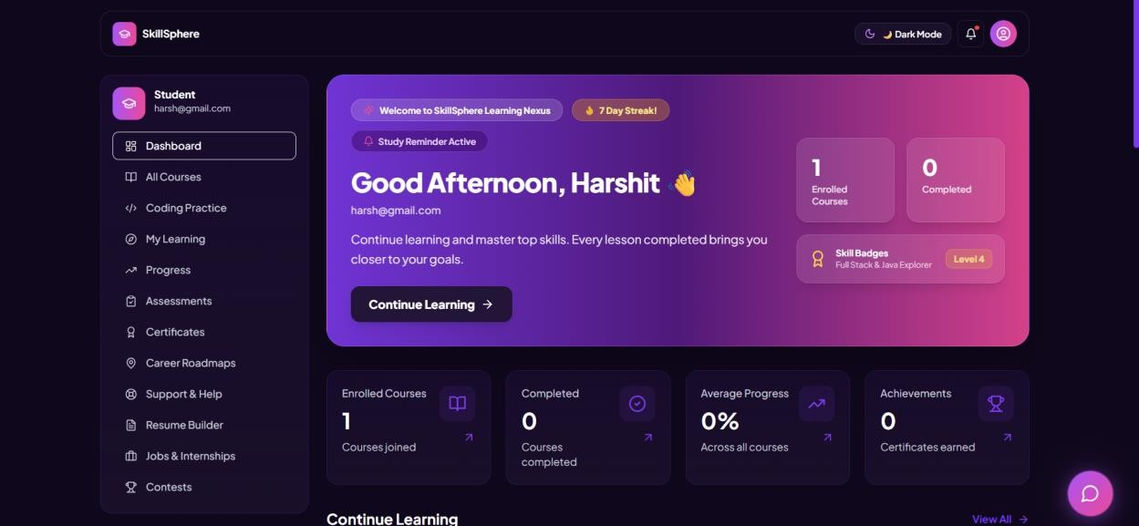
Student Dashboard
Chatting with the AI Assistant is also available across the application.

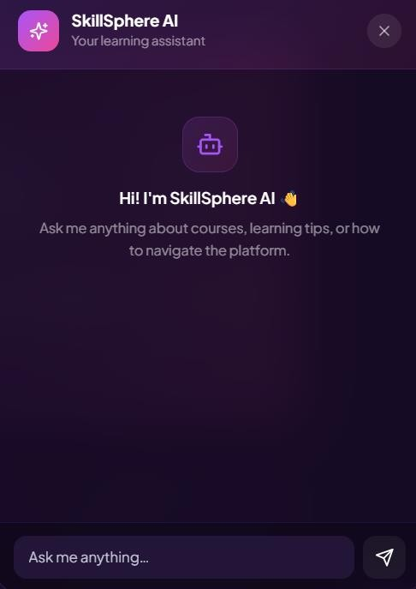
AI Assistant chatbox — your learning assistant

Challenges Faced
During development of the Enterprise Learning Platform, several technical and operational challenges were encountered:

Integrating JWT Authentication with Google OAuth2:
One of the main challenges was combining email/password login and Google Sign-In into a single, stateless JWT-based authentication system.

Designing a Scalable Course Hierarchy:
Modeling Course → Module → Lesson with accurate progress roll-up required careful database and API design.

Automated Certificate Generation & Verification:
Ensuring certificates were generated only once per passed assessment, with a unique ID, QR code, and public verification, was a complex task.

Real-Time Coding Practice & Contest Evaluation:
Building an in-browser code editor with automated test-case evaluation and a live leaderboard required careful backend and frontend coordination.

Database Management:
Managing many interrelated entities (users, courses, certificates, contests, roadmaps) with MySQL and JPA/Hibernate required careful schema design.

AI Assistant Integration:

Integrating the Google Gemini API and ensuring the chatbot responds correctly to platform-related queries was another challenge.

Frontend and Backend Communication:
Ensuring smooth, role-based communication between the React frontend and Spring Boot backend through REST APIs required debugging and testing.

Ensuring Smooth User Experience:
Making sure that all modules — dashboard, courses, roadmap, resume builder, jobs, contests, and AI Assistant — worked seamlessly together was a significant challenge during final integration.

Learnings & Skills Acquired

Java & Spring Boot:
Understanding Java and Spring Boot was essential for developing the backend logic, REST APIs, and business rules of the application.

Spring Security & JWT:
Knowledge of Spring Security helped in implementing stateless authentication, role-based access control, and protecting API routes.

Frontend Development:
Skills in React, Vite, and Tailwind CSS were required to design responsive and user-friendly interfaces such as the landing page, dashboard, and career roadmap.

Database Management:
Knowledge of MySQL and JPA/Hibernate was required to design and manage relational data across courses, enrollments, and certificates efficiently.

RESTful API Design:
Understanding how to design clean, role-gated REST endpoints was necessary to connect the frontend and backend reliably.

Google OAuth2 & Gemini API Integration:
Learned to integrate third-party authentication and AI services securely into a Spring Boot backend.

Data Visualization:
Knowledge of visualization libraries like Recharts helped in displaying learning analytics through charts and graphs on the dashboard.

Problem Solving and Debugging:
Strong debugging and problem-solving skills were needed to fix errors, integrate different components, and ensure smooth functionality of the system.

Testimonials from team

Team Member 1:
“The project helped in improving analytical thinking and practical knowledge in full-stack development, secure authentication, and career-guidance system design while working on a real-world enterprise learning application.”

Team Member 2:

“Working on this project strengthened problem-solving abilities through tasks such as backend development, database design, and implementing the certificate and career-roadmap systems.”

Team Member 3:
“The development of the platform enhanced technical skills in Java, Spring Boot, database management, and AI-assisted system design while providing experience in building real-world applications.”

Conclusion
The Enterprise Learning Platform with Skill and Career Guidance System project successfully demonstrates the integration of secure full-stack web development and AI assistance to create a complete learning-to-career platform. The platform allows students to track learning progress, earn verifiable certificates, practice and compete on technical skills, and follow a structured career roadmap, while providing career-readiness tools such as a resume builder, a jobs board, and an AI Assistant. Through this project, practical knowledge of Java, Spring Boot, React, database management, and AI API integration was applied to build a real-world application. Overall, the project highlights how technology can be used to guide students from structured learning to career readiness.

Acknowledgements
We express our sincere gratitude to Infosys Springboard for providing an excellent learning environment, industry-oriented curriculum support, and access to valuable resources that helped in the successful development of the Enterprise Learning Platform with Skill and Career Guidance System project.
We extend our heartfelt thanks to Shakthi Gopala Krishnan, our mentor, for continuous guidance, constructive feedback, and encouragement throughout the project development process. The insights and suggestions provided played a significant role in improving our understanding and refining the implementation of the system.

